# Exercise: State Management

Problems for exercises and homework for the [“C# Web Basics” course @ SoftUni](https://softuni.bg/courses/csharp-web-development-basics). Yoy can submit your solution in the course web page.

# Part I: Application Development

**Before you begin make sure you have implemented the Web Server from the previous lab.**

You can use similar file structure for your applications:

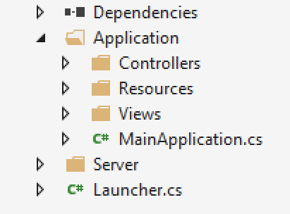

## First Web Site – By The Cake App

Create application called **ByTheCake**. Create a main page that contains **h1** header **“By the Cake”** and **h2** header **“Enjoy our awesome cakes”**. Put a **horizontal line** afterwards. The path to the page should be **"localhost:{port}/".**

### Example

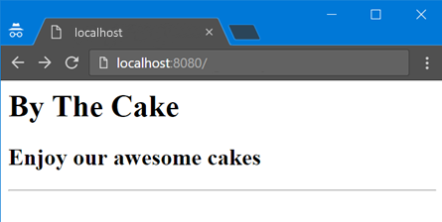

Hint: Create file index.html and place it in the Resources folder. You can read the html from the index file and return it as a response.

## By the Cake: Add Menu

Extend your main page. **Add a menu** as an **unordered list**. It should have four menu items. The Home item should have an ordered sub list with two list items. See the example below.

### Example

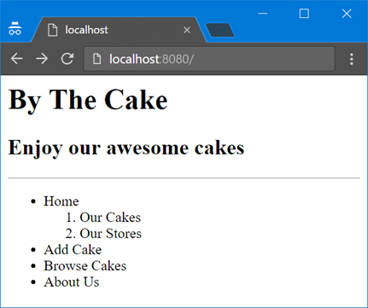

## By the Cake: Add Paragraph

Extend your web page. Add **h2** header called **“Home”**. It should have **two sections**. Each section has a **h3 header**, a **paragraph** and **an image**.

**Section one** should be with header **“Our cakes”**, paragraph with the following **text:**

*Cake is a form of sweet dessert that is typically baked. In its oldest forms, cakes were modifications of breads, but cakes now cover a wide range of preparations that can be simple or elaborate, and that share features with other desserts such as pastries, meringues, custards, and pies.*

and a **random cake image**.

**Section two** should be with **header “Our Stores”**, paragraph with the following **text**:

*Our stores are located in 21 cities all over the world. Come and see what we have for you.*

and a **random cake store image**.

### Example

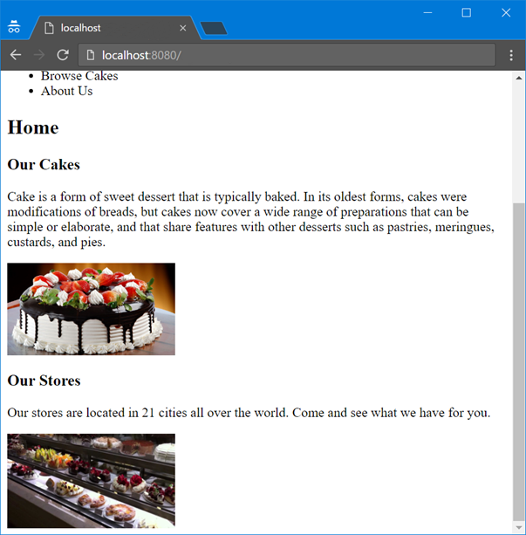

## By the Cake: Add Links

Extend your web page. **Add links for the menu we have**.

* **Home** item should reference **your current page "localhost:{port}/ "**.
* **Add Cake** should reference to "**localhost:{port}/add"**
* **Browse Cakes** should reference to **" localhost:{port}/search"**.

### Example

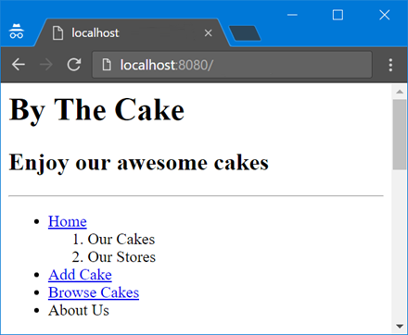

## By the Cake: Add Anchors

Extend your web page. Add an **id attribute** to **h3** **Our cakes** with value “**cakes**”. Add another id attribute to **h3** **Our stores** with value “**stores**”. The menu item “**Our cakes**” should reference to “**cakes”**. The menu item **Our stores** should reference “**stores”**.

### Example

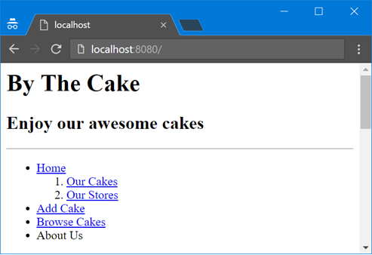

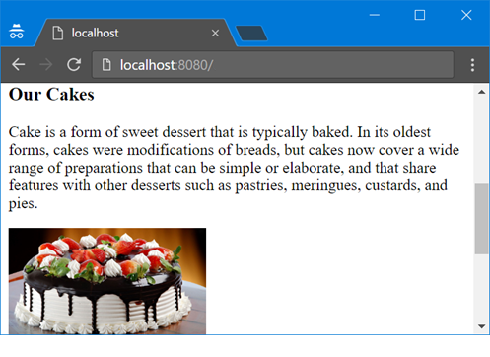

## By the Cake: Add Footer

Extend your web page. Add **footer** which says **©All Rights Reserved**. There should be a **horizontal line above the footer**. **Center the text**.

### Example

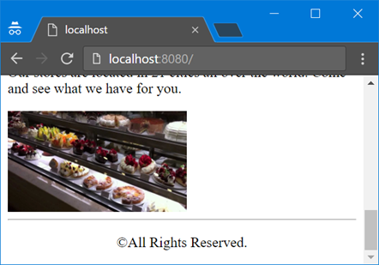

### Hint

* Use the **<footer>** tag
* To center the text of your paragraph **use CSS**. Consider the **text-align**property.

## By the Cake: Add Head

Extend your web page. Now it is time to **add some meta data**. We need to set the following properties:

* **Title**: By the Cake
* **Charset**: UTF-8
* **Description**: Buy the cake in By the Cake
* **Keywords**: cakes, buy
* **Author**: Your name

The meta data will help search engines to recognize your web site as a best match.

### Examples

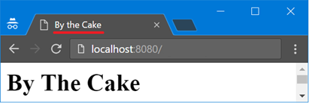

### Hint

Use the **<head>** tag

## By the Cake: Add Stores Info

Extend your web page. Add **preformatted text above the footer** and below the last picture. Change the **background color** to **#F94F80**. The text should contain information about the stores as follows:

|  |  |
| --- | --- |
| City: Hong Kong Address: ChoCoLad 18 Phone: +78952804429 | City: Salzburg Address: SchokoLeiden 73 Phone: +49241432990 |

### Example

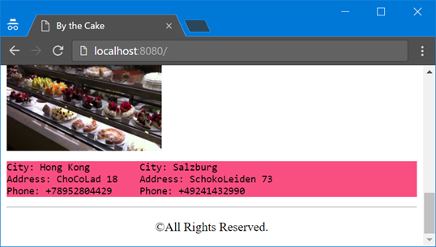

### Hint

* Use **<pre>** tag
* Use CSS only to change the background color

## By the Cake: About Us Page

Extend your web site. Create **About Us page** with **h2 header** with text “**About us**” and path "**localhost:{port}/about**" followed by a **definition list**. Put the information just above the store info. The definition list should have two texts with a single definition each.

* By the Cake Ltd.
  + Company Name
* {Your Name}
  + Owner

Create an anchor that will lead to “About us” just like in Exercise 5.

### Examples

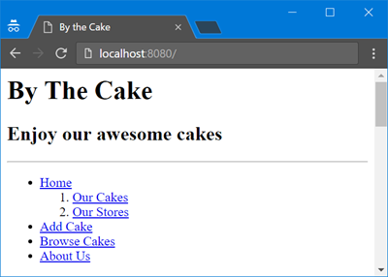

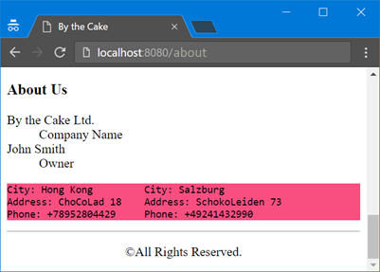

## By the Cake: Emphasize the Words

Extend yourmain page. Find the words **sweet desert, cake, store** in all paragraphs and make them **bold** and *italic*.

### Example

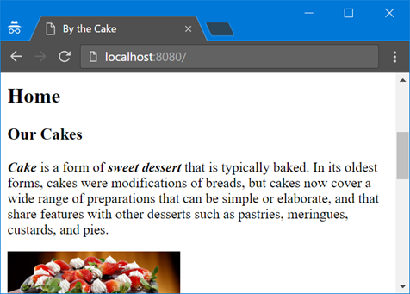

## By the Cake: Add Page

Extend your web site. Create a page which will be responsible for adding cakes functionality. The page should have path "**localhost:{port}/add**". It should have a simple form to add cakes. **Create a Cake class**. Each cake should have name and price. When you click the submit button a new cake should be created and saved in a list. The newly created cake should be printed below the form. **“name”** and **“price”** are the parameters of the request.

**In order for the form to work create a functionality which processes POST requests.**

### Example

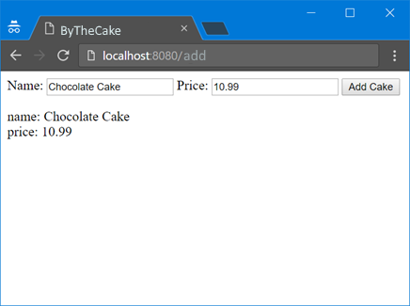

### Hint

Use the method attribute of the form to pass a POST request and the property FormData of the HttpRequest object to obtain parameters.

## By the Cake: Write data

Extend your web application. The submitted data should be appended on a new row split by comma in a file called **database.csv**. Add a link to go back to your main page ("localhost:{port}/").

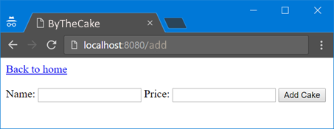

## By the Cake: Search Cakes

Extend your web site. Crate a new page that contain a single form **with GET method**. The path to the page should be "**localhost:{port}/search**" See the example below. It will be used to **search cakes by name**. Cakes should be searched from **database.csv** and printed below the form.

Add a functionality to go back to your main page (**"localhost:{port}/"**).

### Example

|  |
| --- |
| **database.csv** |
| Chocolate cake,10.99 Banana cake,8.59  Strawberry Cak, 10.54 |

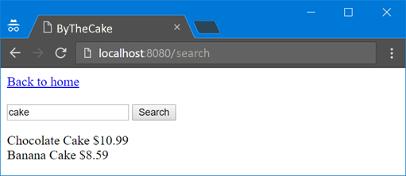

# Part II: State Management

## Login Users

Create a Login page with simple form that asks for username and password. Since we are not using any database for now we are not going to register users. So the user will be logged in with any username and password.

After successful login the user should be taken to the home page **"localhost:{port}/"**.

If the user tries to access any page without being logged in, he/she should be taken to the login page.

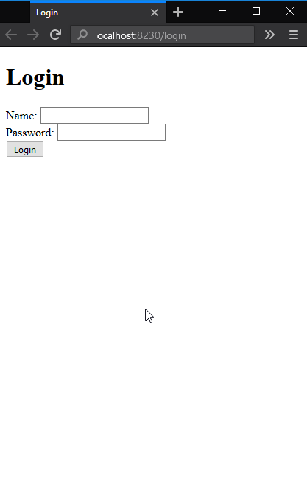

## Keep the User Logged In

After the log in the user should access any page of the application without being asked to log in.

## Implementing Cart

Extend the search page. Add a button "Order" next to each cake.

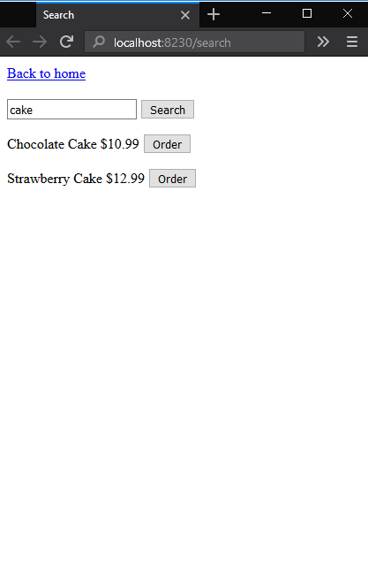

After submitting an order the page should show the count of ordered cakes. The link "Your cart" should navigate to a cart page.

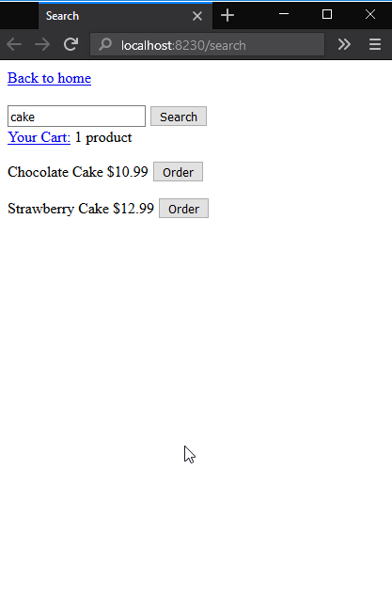

## Implement Cart Page

The cart page should list the ordered cakes and the sum of the order.

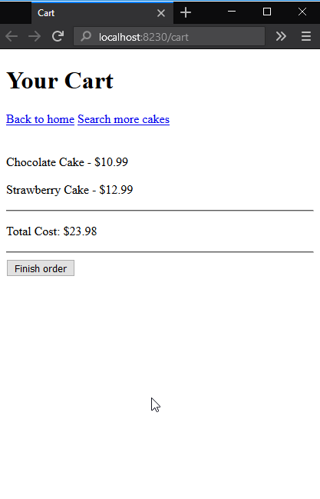

## Finishing the Order

The button "Finish order" should clear the cart and show a page with success message.

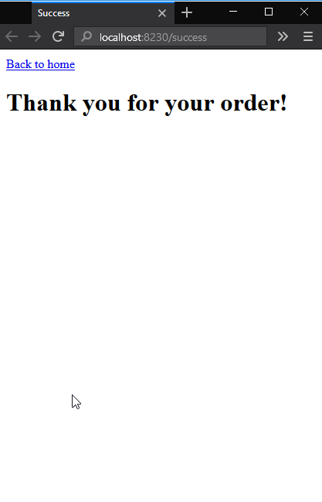

## Implement Logout

Add button "Logout" to each page. When the user press the button he/she should be logged out and the cart should be cleared.